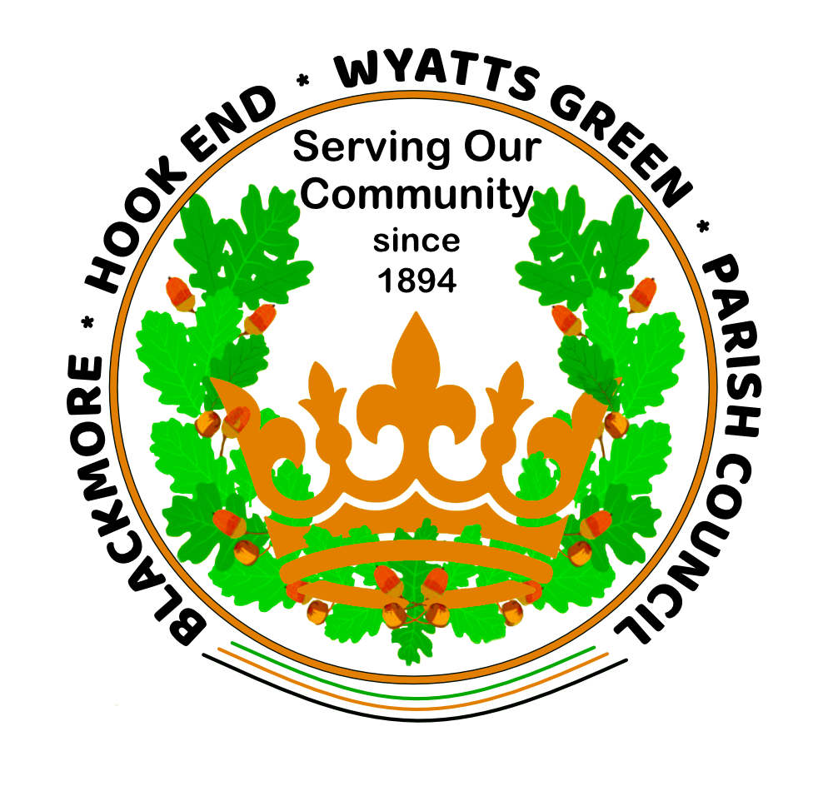

ANNUAL MEETING OF BLACKMORE, HOOK END & WYATTS GREEN PARISH COUNCIL
MINUTES

Held on Thursday, 20th May 2021 in the Blackmore Youth Centre. All Government Covid guidelines were in place and the meeting assembly was within the venue’s Covid capacity. After brief housekeeping given by the Chairman the meeting commenced at 7.30pm.

Members present: R Keeble (Acting Chairman), N McCarthy, K Bennett, H Cannon, A Watley, T Lockhart, T Hinton, T Thomas, J Clarke, S Clapham (Parish Clerk) and R Nelson (RFO). Borough Cllr(s) Peter Jakobsson and Thomas Bridge. Essex County Cllr Lesley Wagland. Mr and Mrs Smith – Herald Magazine Editors. Also present, Judy Lewis (to be co-opted).
Apologies for absence: Cllr Vic Dean.

0001 ELECTION OF CHAIRMAN
Nominations were invited from Councillors. Cllr McCarthy proposed Cllr Roger Keeble as Chairman, Cllr Cannon seconded and Cllr Keeble was unanimously elected to this position. Cllr Keeble accepted to continue the role of Chairman and duly signed the necessary paperwork. Cllr Keeble opened the first face-to-face Council meeting since March 2020 and wished to remember all those locally who had been affected, or had lost their lives or family members to the current Covid-19 pandemic. It had been a very challenging year for everyone and the PC was pleased that it had been able to continue its meetings and business remotely during this period and noted that the Zoom meetings had been very successful.

0002 ELECTION OF VICE CHAIRMAN
Cllr Ken Bennett proposed Cllr Lockhart; this was seconded by Cllr Keeble and unanimously confirmed. Cllr Lockhart confirmed acceptance of this post.

0003 CO-OPTION of Mrs Judy Lewis (for the Hook End and Wyatts Green ward)
The Clerk confirmed she had carried out the necessary checks with the Elections Office at
Brentwood Borough Council. Therefore, Mrs Lewis was co-opted onto the Parish Council and
Signed the Register of Acceptance of Office. The Members welcomed her to the PC.

0004 ELECTION OF COMMITTEES AND CHAIRMEN
Cllr Lockhart had confirmed his willingness to remain as Chairman of the Planning Committee. Cllr Watley had also confirmed his willingness to remain as Chairman of the Parks and Open Spaces Committee. It was also confirmed that Committee members would also stay the same. The Clerk will circulate an up-to-date contact list to all Members. Presently, Cllr Hinton and Cllr Lewis were not free to join any Committees.

0005 APPROVAL OF MINUTES – 22.4.2021
The minutes were signed as a correct record by the Chairman.

0006 DECLARATION OF INTEREST (for items on the agenda)
Blackmore Village Hall – Cllr Cannon and Cllr Keeble (BVH Committee Members).

0007 OPEN FORUM (for Public Attendees) – none registered with the Clerk

0008 PROGRESS CHECK – Nil

0009 CORRESPONDENCE – Nil – There were no new items since the last PC / Committee meetings and all items were included within the agenda.

0010 REPORTS OF BOROUGH AND COUNTY COUNCILLORS
- Cllr Jakobsson reported that he had been made Vice Chairman of the BBC Planning, Housing and Communities Committee and had joined the Audit and Scrutiny and Disciplinary Committee.
- Cllr Bridge reported that during his Electioneering Campaign he had received several issues or concerns from local residents. He had been told of a Kiln Field tree problem which the Clerk had discussed with him in more detail confirming that Kiln Field is owned by BBC and not the PC and would need to be addressed by them. He had also noticed that some of the graves in St Laurence Church, Blackmore were in need of some care and attention, which he had reported to the War Graves Commission.
- The BBC Cllr’s advised that the next BBC NAT’s visit was scheduled for 14th June so items would need to be processed via them in the usual way.
- Cllr Wagland reported that ECC is under new leadership of Cllr Kevin Bentley, with Cllr Louise McKinlay as Vice Chairman. Cllr Wagland has been made Cabinet Member for Economic Renewal Infrastructure and Planning. Cllr Wagland hoped to be free to reinstate the weekly Teams meetings with the Clerk and her assistant Ann Cocklin dealing with local Highways issues. Kerbstones were discussed at Meadow Rise and Plovers Mead and it was hoped that repairs would be imminent. Kerb stone repairs are generally undertaken as planned maintenance via the Local Highways Panel. If there were particular areas of concern they could be given to the PC’s Highways representative Hugh Bourton who would address these at the LHP meetings.

POLICY & RESOURCES
0011 Finance - Payments made online:
S Clapham -
Pension -
HMRC -
R Nelson -
Graham Bonney – £360.00 - Fertiliser spreading on Walter Hobbs field
BBC - £2,077.92 – Dog/litter bin emptying – period 1st October 2020 to 31st March 2021
DGL (Stuart Allan) - £15.00 – Pedestrian footway sign repair
O’Riordan Construction Ltd – £504.00 (inc. VAT)- To repair three damaged and rotten signs
Total Landscapes Ltd - £340.00 – To install memorial bench for Judy Wood’s husband Peter, which she has since reimbursed
ROSPA – £318.00 (inc VAT) 3 x site play area inspections
MDL - £822.84 (inc.VAT) – Grass cutting
Scott Norris - £512.50 – Allotment field rent

It was RESOLVED that:
- The statutory basis for this item be noted as the Accounts and Audit (England) Regulations 2015;
- The List of Payments is approved as presented in the schedule.

Payments made on the PC Credit Card: Nil

Cash drawn - Nil

Transfers – On 29th April £40,000.00 was transferred from Barclays Account to Unity Trust to meet online payments.

Mini Bus
Insurance Renewal 4.5.2021 – Fully Comprehensive cover put in place with Gallagher Insurance costing £478.79
Annual Inspection and MOT/TAX – Action: To be organised by the Clerk
(Still Temporarily out of use & off-road SORN declaration).

Income/receipts:
£800.00 - Reimbursement for Peter Wood’s Memorial bench on the Green.
£2,249.58 – HMR&C VAT refund for period January to March 2021

Membership renewals/subscriptions: Nil

0012 Financial Report to 30th April 2021
Mrs Nelson reported on the financial reports as distributed prior to the meeting as outlined above. All approved and accepted with no amendments.

Financial Powers
0013 BBC Precept Overcharge – A meeting with BBC to discuss their 1.5% overcharge error is pending.

0014 Draft Accounts ready for Audit on 3rd June (as circulated and approved).

0015 MAGAZINE COMMITTEE – Parish Council Year Book (2021/22)
Mr Smith reported that the copy was finally ready to go off to the Printers next Monday, giving a deadline for alterations up to Sunday 23.5.2021. The Year Book would then be back in approximately two weeks for distribution.
At the end of March 2020 there was a debt for non-payment of adverts of £480.00. However, £120.00 had been paid during 2021 giving a new debt of £360.00. All advertisers paid in advance to appear in the 2021/22 Year Book totalling £1952.00 which had been banked.
This meant that with the inclusion of colour covers and inserts totalling £210-220, plus postage costs, the 76 page Year Book should show a profit of approximately £360.00. The Members were delighted that the Year Book had not only paid for itself but had also realised a small profit and thanked Mr and Mrs Smith for all their continued hard work and support to its publication.

PLANNING COMMITTEE
0016 Planning applications were dealt with by Committee Members on 5th May 2021 and the Planning Committee Chairman emailed the reports to the BBC Planning Department. The reports were approved by full Council. Cllr Lockhart read out his report:

Planning applications considered:
- La Valette, Hay Green Lane, Hook End – various extensions (re-submitted application) (21/00709/HHA) (no objection)
- 16 Fingrith Hall, Fingrith Hall Lane, Blackmore – rear extension (21/00694/HHA) (no objection)
- 37 Plovers Mead, Wyatts Green – rear extensions (21/00732/HHA) (no objection)
Cllr Cannon had raised queries in respect of 2 sites in Blackmore, namely 4 Westbrook Cottage and Fyrtles, both in Blackmore Road. As they were in the Conservation Area, Roger said he would speak to Paulette McAlistair, the Conservation Officer. He has had a reply back from Enforcement to say that they had contacted Mr Taylor at No4 and instructed him to cease work until he had contacted Planning. As a consequence of that he has made a Pre-application. The owner of Fyrtles is working with Paulette to determine what they can and cannot have. The temporary buildings in the rear garden are allowed whilst the refurbishment takes place.

It was generally felt by the members that we should continue holding our planning meetings on Monday mornings. If we met face to face, which is now allowed, it would have caused a problem with accommodation at the Village Hall and Tipps Cross Hall. Although full PC meetings must now be held face to face, committee meetings appear to be exempt. It was therefore decided to continue holding the Planning Committee meetings by zoom which has worked well so far – they were more convenient and less time consuming and members of the public are more than welcome to attend. If they contac the Clerk she will send them the relevant link.
Cllr Lockhart had corresponded with our new Ward Councillor, Thomas Bridge who has promised to support us where he can by objecting to any future inappropriate developments on Green Belt land within the parish.
Cllr Lockhart has also updated his planning guidance notes to distribute to any of the new co-opted members in anticipation of them wishing to join the planning committee.
Date of next meeting to be set as and when planning applications are received.
Presently, there are no further updates from BBC regarding the LDP Examination.

PARKS & OPEN SPACES
There had been a POS Committee meeting on Monday 17th May 2021 at 10.00am via Zoom. The minutes, as circulated, were approved by the Council. The following items of business were discussed:

0017 Annual (RoSPA) play area inspections 2021
The inspection reports from the ROSPA inspector were circulated to all members by the Clerk for consideration. This will be added to the next POS meeting agenda in June. Invoice received for payment.

0018 Millennium Park:
cockleshell footpath – In hand with Cllr Keeble and Contractors.
Children’s birthday party 22.5.2021 – Cllr Cannon and the Clerk are meeting with the applicant on 20.5.2021 at 11.00am to discuss arrangements. Due to the inclement weather it may have to be moved to the Village Hall.

0019 Blackmore Youth Football Club event 2.7.2021
Cllr Cannon had circulated to all Members details of the enquiry and the responses she had received to her queries from the Youth Football Team Committee. Cllr Cannon reorted on the meeting held with the Football club and outlined their requests to the Council. TheYouth Football Club Committee had asked if they could hold the event on the Walter Hobbs field if England were not playing and use the Millennium field if England were playing. The Youth Football Team were hiring an outdoor large TV screen, inflatables and a stage for the presentation. They estimated between 350-400 people attending, although it was hoped that this would not be reached at any one point as there would be several presentation slots during the evening and people were expected to come and go, although this was not guaranteed. The Parish Council considered the details and felt that the Walter Hobbs playing field would not be a suitable venue to hold the event, which may also clash with the Sports and Social Club’s own football event. There was also the concern of unavoidable potential damage being done to the football and cricket pitches which have just had field treatments. It was therefore proposed and unanimously agreed that the Millennium Field could be hired out to the Youth Football Club for the duration of the event and not the Walter Hobbs field. A concessionary price of £200 was agreed. The Council stipulated that as part of the Terms and Conditions of hire, the Youth Football Club’s event would be a ticketed event to avoid unmanageable numbers attending. Also, the Football Club’s chosen contractors/suppliers/caterers must have the required level of Public Liability insurance in place, they must also organise and maintain suitable and adequate marshalling of the event and ensure that all Licences are in place i.e. a TENs licence if required. The Club is to check this with Brentwood Borough Council (a copy of this will be forward to Dave Lenoard at BBC).
Also in the usual way, all grounds/facilities/amenities must be reinstated by the hirer if any damage was to occur.

0020 The Keep Britain Tidy Campaign between 28th May to 13th June 2021
It was agreed that Cllr Keeble would oversee the litter pick on 12th June at Blackmore and Cllr McCarthy the Hook End and Wyatts Green area. Equipment to be collected from the Clerk.

0021 Mill Lane
Meeting scheduled with Playquip Leisure on 25.5.2021 to discuss options for toddler equipment (plus a gate for Ted Marriage). This will be added to the POS Committee meeting in due course.

0022 Memorial requests – The Green, Blackmore
The Clerk has four requests in hand and is liaising with the applicants. As discussed at the POS Committee meeting, the PC considered whether people living outside of the parish could have a commemorative item in the parish, and it was proposed by Cllr Keeble and agreed that they could.
It was also suggested by Cllr Watley that the tree proposed for the Green could commemorate HRH The Queen’s 70th anniversary on the throne. This will be considered by the POS Committee nearer the time of planting.

0023 CLERK’S REPORT (Governance)
- Face to face meetings resume for full Council meetings from 7.5.2021.
- Remote meetings via Zoom – It was agreed that for the time being the committee meetings would meet remotely via Zoom due to a lack of availability of a suitably Covid safe venue. Members of the public were still welcome to attend and contribute upon application with the Clerk.
- New PC accessible website – Cllr McCarthy reported that the Cabinet Members dealing with the PC’s application for a new .gov.uk domain name had decided that the PC could not have the domain name of blackmorepv.gov.uk, and had to incorporate its name in its entirety – i.e. blackmore-hookend-wyattsgreen.gov.uk. Cllr McCarthy will report when the website goes live shortly.

0024 DATE OF NEXT MEETINGS –
POS – 14th June 2021 at 10.00am – Zoom.
PC – 17th June 2021 – Blackmore Youth Centre.
Planning – TBC – Zoom.
BBPCA – 16th June – Teams

INFORMATION EXCHANGE/NEXT AGENDA ITEMS
0025 Nil.

CLOSE OF MEETING
There being no further items of business, the meeting closed at 8:40pm.

Signed……………………………………………………. Dated ………………………………

