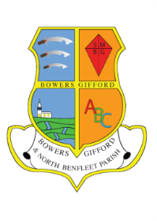

BOWERS GIFFORD & NORTH BENFLEET

PARISH COUNCIL

Publication of Photographs Policy

- All official photos will be taken by a designated person acting on behalf of the Council and identified as appropriate for the occasion.

- All photographs of children, competition winners and the general public will be used only in connection with Bowers Gifford & North Benfleet Parish Council business via:

- Parish Council website
- Newsletters /leaflets,
- Posters
- Events
- 3rd party partner organisation only for publication and publicity.

- Where appropriate, in regard to any individual child under 16 years old, written consent to publish will be obtained from the young persons’ parent/guardian.

- Posters informing the general public of the Parish Council’s intention to publish will be displayed prominently at events where photographs are to be taken.

- All posters where photographs are used will contain the name of the Parish Council and contact details of whom any enquiry should be directed to. Leaflets and newsletters will provide the same information.

- Any photograph used expressly for Parish Council business i.e. used in hand delivered publications, inserted in newspapers, at events and any venue etc. used to publicise the Parish Council will carry the notice as in 4 & 5 above.

- The Parish Council will take all possible measures to limit any harm or damage to the individual/s concerned by following the above procedures.

Ref: Adopted at the Parish Council meeting held on 29th October 2014

