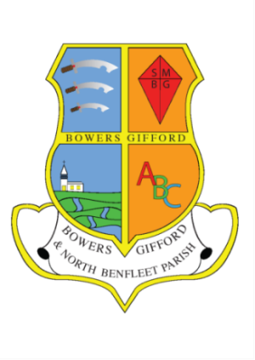**26**

**Bowers Gifford and North Benfleet**

**Parish Council**

**ANNUAL PARISH MEETING**

**WEDNESDAY 26th APRIL 2023**

**7.30 P.M.**

**THE BENBOW CLUB, POUND LANE**

1. **Welcome to electors**
2. **Councillor Bernard Foster, Chair, to provide an overview of the Parish Council year.**
3. **Question time - an opportunity for residents to ask questions or raise issues with their Councillors.**

**THIS MEETING WILL BE FOLLOWED BY:**

**THE PARISH COUNCIL MEETING**

**AT 8.15 P.M.**

** **

**Councillor Bernard Foster Christine Barlow, Parish Council Clerk**

**Parish Council Chair 01268 725236 (M) 07758255621**

**BOWERS GIFFORD & NORTH BENFLEET**

**PARISH COUNCIL**