BOWERS GIFFORD &
NORTH BENFLEET
PARISH COUNCIL

ANNUAL PARISH MEETING

THE BENBOW CLUB, POUND LANE

WEDNESDAY 29th APRIL 2015

7.00 – 8.15 p.m.

- Welcome by the Chairman of Bowers Gifford & North Benfleet Parish Council, Councillor Robert Smillie

- Chairman’s Report

- Questions from electors

- A brief introduction to Neighbourhood Planning

- Close of meeting

THIS IS A PUBLIC MEETING AND ALL
ARE CORDIALLY INVITED TO ATTEND.

AMPLE TIME WILL BE GIVEN FOR THOSE ATTENDING TO RAISE ISSUES RELATING TO BOWERS GIFFORD & NORTH BENFLEET.

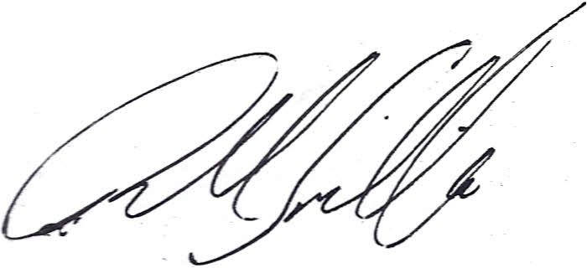
Cllr. Robert Smillie
Chairman 22.4.15

