AIRTHREY SPA BOWLING CLUB
MINE ROAD
BRIDGE OF ALLAN
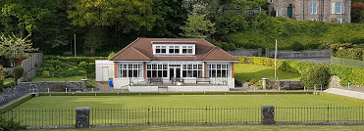

In Case You Were Wondering...
Yes, we will re-open hopefully on 10th April, restrictions dependant

Yes, we will be operating safely with social distancing measures in place

Yes, we are looking for new members, ladies and gents

Yes, you are most welcome

For further details please: email airthreyspa@gmail.com
Visit our Facebook page Airthrey Spa Bowling Club
Visit our website e-voice.org.uk/asbc

