Patron: Yvonne Minton C.B.E Hons. R.A.M
I am happy to be Patron of the River Crane Sanctuary which was founded to raise awareness of the stretch of River Corridor from Kneller Gardens to The Shot Tower following attempts by private owners of MOL/Green space and designated SMINC to build on or near protected areas.
Neighbours and River Crane nature lovers value this amenity and many were unaware of the existence of these areas in private ownership which are in need of more robust oversight given we have lost our Park Wardens and the Local Authority has many financial constraints to police all areas within its remit.
Nature Conservation is under threat everywhere and we promote interest and proactive involvement by supporters to preserve, protect and enhance what is here already for the benefit of all. We support F.O.R.C.E and S.W.L.E.N in their more organised and historical work along the whole River Crane Corridor/Environment and add our objection below to their professional and convincing arguments to stop this inappropriate development
To this end we have commissioned professional advice to submit the below valid objections/comments for refusal of this application along with testimony/photographic evidence from our supporters who have lived in this immediate area for decades and have knowledge of the value of the site as a habitat and dark, quiet and unique space which is rare in our crowded urban sprawl.
I urge the Committee to look critically at the photographic and expert evidence supplied by the Applicants and which we have reason to challenge on accuracy and the submitted out of date reports on vital issues which affect this build and nature conservation in particular.
---------------------------------------------------------------------------------------------------------------------------
View of Site in May 2019 Magnificent habitat for wildlife – Hawthorn, ‘scrub’, fruiting ivy
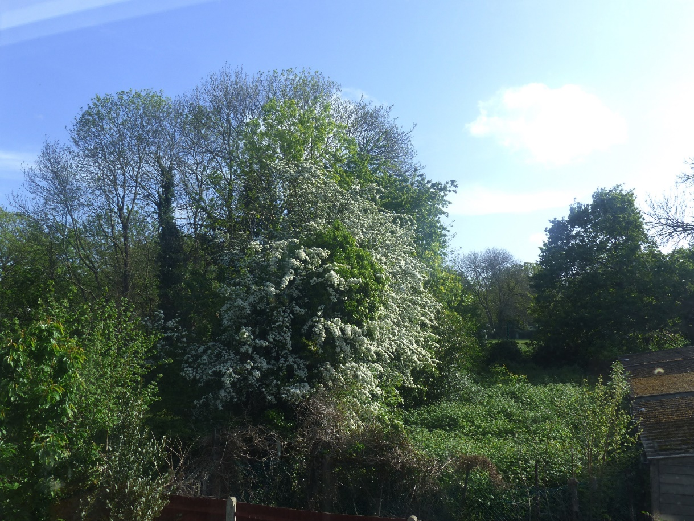

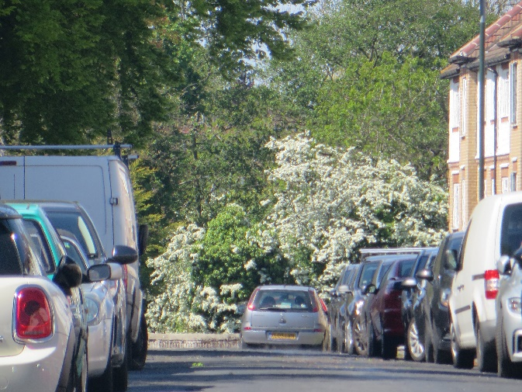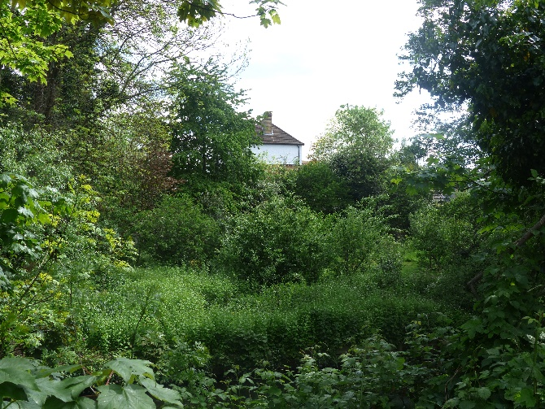
1.Churchview Road to site showing car parking 2. Sontan Court view from public River Walk

There is no pavement from Sontan Court for children and adults to walk down this road. The exit from the flats is straight onto the road with cars turning by the garages or going to park behind the flats. Four more car spaces are proposed on the left verge which is used to walk down when heavy traffic or just walk in the road! A large refuse facility is proposed, across this road, for the New Builds and Flats usage and next to Campbell Close gardens/kitchens. Safe, Hygienic, Neighbourly?

Regular clearing and maintenance of site (photo 1: May2017) Maintained for decades by the Owner’s Caretaker (Property Agents and Communal charge for these areas apply or someone has been paying and instructing the Caretaker to maintain these areas and when not to do so such as the destruction of the compost heap without any care for invertebrate presence.) Photo is showing the verdant hedgerow and fruiting Ivy before October 2017 ‘mistake’ by Developer’s contractor with small digger destroyed all the self-sown vegetation and their photo evidence. in their Application presentation documents showing the mess and so-called dumping only appeared after this ‘mistaken’ action and which we ask to be viewed in this context.

The day before this ‘mistake’ we had wild bees on the left vegetation, a flock of redwing and presently we have Red listed Starlings, Songthrush, Dunnocks and House Sparrows on the greening garage roofs and the brambles. The ‘scrub’, (which will be removed if this application is granted along with the overhang areas of established greenery areas on the left) are feeding and housing numerous birds and wildlife although recent thinning and clearing by the MOL owners has severely reduced the density of this hedgerow.
Photo 2 is the view from the Green Gym in the Meadway towards the site and across Trafalgar Infant School Playing field. The open views of trees and greenery will have the three storeys build in the foreground and will block the full view of the Lime tree for all visitors from this angle including our children in the school. Instead they will see another building crowded into a small space and endure the lengthy noise and disturbance from the build itself.

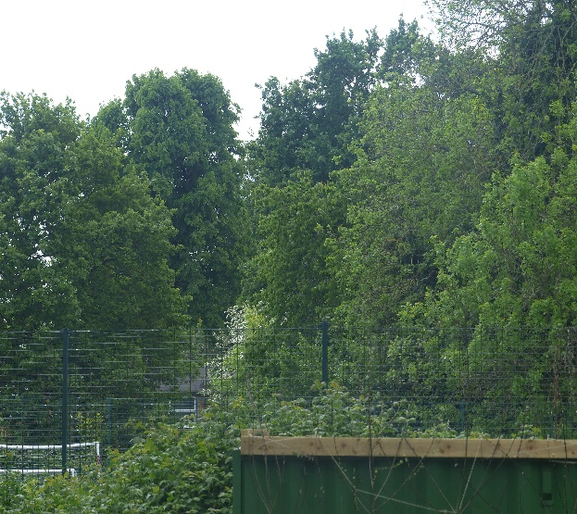
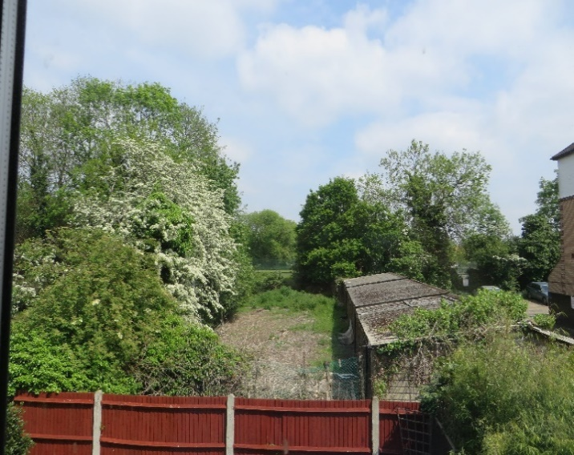

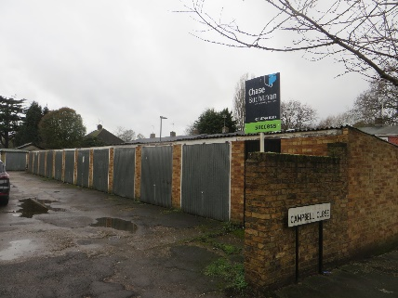
This is not a derelict and under used area which has been said meets criteria for re-development and improvement. It is a widely used area by wildlife and by nature lovers who get the benefit of watching the wildlife who rest and feed here. The garages are sound and dry by the Applicants’ own reports and they have a value on the open market of c.£25.000. A Garage in Campbell Close sold immediately this month and is similar in size and older. Saying we need bigger garages for bigger cars is crooked thinking in an age where we need no cars at all or smaller eco cars. The Developers can sell or rent these garages easily and take cars off the road; not create more car parking spaces next to a school and gardens. Or let the bikes and storage have it.

Many have enjoyed the uniqueness of this space for years as a past supporters of the Crane Community Centre activities and as visitors to Campbell Close gardens and the River Walk which all have views towards this so called ‘waste land’ by the Developers and which is not wasted at all but supports a multitude of wildlife and sustains the spirits of all of us who need peace and nature in an increasingly loud and busy world. These areas are linked and form corridors for the foxes in Trafalgar site to roam into these areas and support endangered wildlife such as hedgehogs who are recorded right here. We are not convinced by the benefits of communal space offered to the Flats residents which looks very ‘nice’ but seems unlikely to be used except by the freeholder new owners and challenge the improvements this will make to the land itself as only cosmetic compared to what is already there under the ground and in the habitat of wild, un-inhabited space. Stag beetles, Songthrush and much more. Human and domesticated animals in this narrow space will have an impact not only on neighbours with additional noise but also potential usage of pesticides and inappropriate activities on this sensitive site. The buildings do not seem to offer family accommodation or specific target group accommodation for the elderly, for example, but states in its design data that the rooms/areas are policy compliant for two people occupation. The bathroom is on the first floor by the lounge because ‘they cannot comply with the law here because of the narrowness and constraints of the site” Is that acceptable or shows that the site is not suitable for this development? Who is going to buy these two house and occupy them? Multi rentals for young people which will be problematic usage in this space for wildlife and neighbours or buy to let to have an address for access to local schools? Will dogs/cats be allowed when we already have four dogs with 24-hour access behind the build on the MOL itself and 10 dogs in the Close/Road adjacent with numerous cats and when there are signs of No Dogs on Sontan Court wall?

The Council’s commitment in the Local Plan states:
Protecting Local Character
Maintain and enhance the borough's attractive villages, including the unique, distinctive and recognisable local characters of the different village areas and their sub-areas.
This sub-area of West Ward meets all the above criteria and is valued by Residents, Trafalgar School children/teachers/sports field participants and River Crane Walk nature lovers. Three storey buildings in this confined space will destroy the sense of openness, views, enjoyment of photographing and watching red listed wildlife in a relatively quiet space free from extensive footfall. Across the river we have 1000 people a day recorded by FORCE. There is a dawn chorus and evensong here and a multitude of insect life which has been lost in so many places already. It has a local character which is rare and which gives a feeling of not being in a town at all. It is not just the MOL/SMINC adjacent which gives this character it is this particular area which has open skies and views of large trees from many angles and for many people. We respectfully request that the new Appeal Officer (if this goes to Appeal again) re-considers the last Appeal Officer’s comment that we can still see the tops of the trees over the three storey buildings so the criteria of refusal on blocking of open views is not upheld. Two thirds of the trees/hedgerow’s beauty are therefore blocked from view and I wonder if that would apply to only seeing the eyes of the Mona Lisa? Rather misses the point of the experience of seeing the whole picture. The removal of trees along the border with Trafalgar School was said by the Appeal Officer to aid in a small way biodiversity as they were identified as ‘U’ class of limited value and therefore their removal and replacement with new parking bays and re-planting in a limited narrow border was a positive. Following a TPO imposed on the adjacent MOL Land and several trees on the application plot; the area was ‘managed’ and trees removed so we look forward to re-planting and biodiversity improving here in due course and note it did not take the building of two houses to accomplish this as the presumably property management agents for the Flats already have a budget for this work.

In strict legal terms it is true but controversial that loss of a personal view is not protected. We have been advised that does not necessarily mean that it is irrelevant to planning decisions or unenforceable in law. It is a judgement call. Enjoyment of a view is an important part of the residential amenity of neighbouring properties. Loss can have an adverse impact on the residential amenity of the properties and especially if that amenity has been enjoyed for decades. This is a grey area in planning law which says that views which enhance the character and enjoyment of an area/neighbourhood must be taken into account by planning officers in coming to a decision and balancing what is lost against what is offered as gain. We do not agree that the gains outweigh the losses and we cannot see any support for this application but lots for maintaining the vistas, peace, quiet and wildlife already enjoyed by those living here and with views to this space from all four corners of the neighbourhood.

The below criteria for local character and nature conservation issues combined with human needs considerations is also relevant to this application and which we fail to see adhering to the points in bold for the reasons we have outlined and add to below.

2. Protect and, where possible, enhance the environment including the heritage assets, retain and improve the character and appearance of established residential areas, and ensure new development and public spaces are of high-quality design. (The design is limited to a confined base of a garage footprint which means it is not high quality for human habitation space and layout and does not meet criteria for bathroom location and possibly other space issues. The second bedroom on the third floor has windows only towards the higher brick wall of Sontan Court and both new houses have an overbearing and closer proximity to this building only 7.5 metres away.)
3. Protect and improve the borough's parks and open spaces to provide a high-quality environment for local communities and provide a balance between areas for quiet enjoyment and wildlife and areas to be used for sports, games and recreation. (Trafalgar School took over parts of the MOL here and that was a sacrifice worth making for our youngsters and the wider community benefits. This development is not worth the loss of more wild/dark space.)
4. Protect and enhance the borough's network of green infrastructure that performs a wide range of functions for residents, visitors, biodiversity and the economy. 5. Protect and enhance the borough's biodiversity, including trees and landscape, both within open spaces but also within the built environment and along wildlife corridors. (Gentrifying and tidying up a space does not necessarily make it better and can make it worse with introducing lighting into a dark space which will impact on insect numbers breeding and bats feeding here already. How can you improve on established and recorded decades of visiting red/indigenous species wildlife/flora and human enjoyment of nature with a communal lawn and two electric car points.?) 6. Protect and improve the unique environment of the borough's rivers, especially the River Thames and its tributaries as wildlife corridors, as opportunities for recreation and river transport where possible, increasing access to and alongside the rivers where appropriate, and gain wider local community benefits when sites are redeveloped.

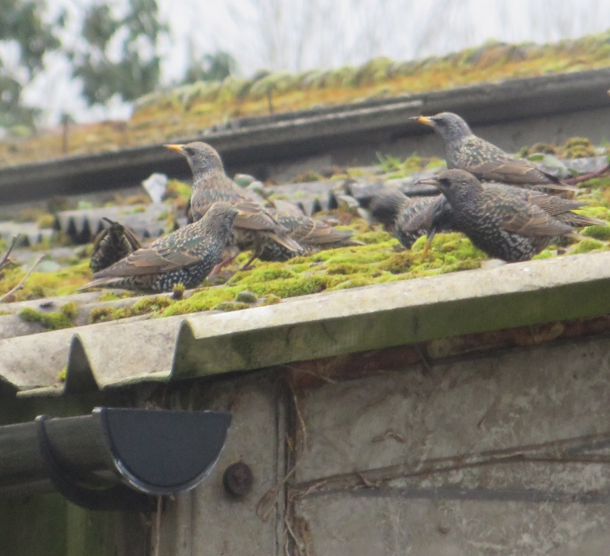

How do we request restrictions if you intend recommending approval to the Committee so you can consider adding them to your report to the Committee.?

We have advice coming from a senior Ecologist and Lawyer which we were planning to use for our three minute slot but we also have more members of our River Crane Sanctuary group wanting to put in an objection and restrictions relevant to the environmental impacts of the build and future usage and we have found some anomalies and inconsistencies in the drawings and communal amenity area offered as mitigation by the Developers and which may have swayed the Appeal Officer's judgement on this application along with the ,maintenence work on the tree line offered to improve Biodiversity and which we note some of which has already been done and new parking spaces installed behind Sontan Court. This did not need two three storey buildings permission to put in place!

They have presumably property management funds and a duty of care for this from residents of Sontan/Churchview Flats and the upkeep of the garages and area behind them was done on a regular basis prior to seeking planning here. They employ a full time Caretaker who lives on site. This 'neglected' area is a deliberate manipulation of the space to get planning through and we will produce photographic evidence and verbal testimony to substantiate our claim of historical clearing and maintenance of this area and no security or dumping issues except for the digger used by the Developer's own agents to clear the area behind 19/20 Campbell Close which damaged our fences footings as decades of fruiting ivy, elder , hawhorn, ash, self sown hazels were cleared 'by mistake' according to the Developers when challenged about the destruction of established habitat

The Caretaker continues to spray the area for bity spiders on the 3 meter right of way access path but leaves the brambles and growth behind the Garages to invade the Wild hedgerow on the MOL land and garage roofs. This could be cleared in one day and the garages are sound and dry according to the applicants with no wildlife infestation and the doors and appearance of the garages from the approach in churchview road are painted, neat and tidy.

As residents we are very concerned to note that the public right of way behind 19/20 campbell close is not highlighed anywhere or permission asked to close it if it is intended to be used for lorries/building works. We were told By Simon Graham-Smith that this area marked in red from 17 to 20 campbell close back gardens bordering 3 metres away from our back fences and in churchview road is not in the planning application and therefore we would like assurances that high boarding will be place here and not just in front the new builds as shown in their building 'good practise' access drawings on line.

How can they access this build without using this side public right of way amenity/access area ?

Can this area be a restricition too for granting the build? It will offer some protection for the wildlife and our small gardens living space 3 metres from the skip and road for the long build time. Not just boarding against our fences but from the build line of application from garage one at the end of Churchview Road to the MOL border.

We would like confirmation that the asbestos on the garage roofs commented on by an objector in the last application has been noted and investigated to establish if this is so and that safeguards are rigourously supervised and put in place to remove them if confimed.

---------------------------------------------------------------------------------------------------------------------------
Protecting Local Character 1. Maintain and enhance the borough's attractive villages, including the unique, distinctive and recognisable local characters of the different village areas and their sub-areas. 2. Protect and, where possible, enhance the environment including the heritage assets, retain and improve the character and appearance of established residential areas, and ensure new development and public spaces are of high quality design. 3. Protect and improve the borough's parks and open spaces to provide a high quality environment for local communities and provide a balance between areas for quiet enjoyment and wildlife and areas to be used for sports, games and recreation. 4. Protect and enhance the borough's network of green infrastructure that performs a wide range of functions for residents, visitors, biodiversity and the economy. 5. Protect and enhance the borough's biodiversity, including trees and landscape, both within open spaces but also within the built environment and along wildlife corridors. 6. Protect and improve the unique environment of the borough's rivers, especially the River Thames and its tributaries as wildlife corridors, as opportunities for recreation and river transport where possible, increasing access to and alongside the rivers where appropriate, and gain wider local community benefits when sites are redeveloped.

3.1.6 The Spatial Strategy emphasises that local community needs, including delivery of housing and the infrastructure required to support it, are expected to be met without compromising the quality of the natural, built and historic environment. This means in particular that the highly valued network of green infrastructure, including its contribution to biodiversity objectives, will be protected, and where possible enhanced. The borough's parks and open spaces provide not only recreational opportunities for those that live and work in this borough, but also for local communities and residents in neighbouring and other London boroughs, by providing a green lung for southwest London. Therefore, there is a presumption against the loss of, or building on, greenfield sites in this borough. The Spatial Strategy and the Local Plan policies, taken as a whole, also set out how development and use of land will contribute to the mitigation of, and adaptation to, climate change.
Policy LP 5 Views and Vistas The Council will protect the quality of the views, vistas, gaps and the skyline, all of which contribute significantly to the character, distinctiveness and quality of the local and wider area, by the following means: 1. protect the quality of the views and vistas as identified on the Proposals Map, and demonstrate such through computer-generated imagery (CGI) and visual impact assessments; 2. resist development which interrupts, disrupts or detracts from strategic and local vistas, views, gaps and the skyline; 3. require developments whose visual impacts extend beyond that of the immediate street to demonstrate how views are protected or enhanced; 4. require development to respect the setting of a landmark, taking care not to create intrusive elements in its foreground, middle ground or background; 5. improvements to views, vistas, gaps and the skyline, particularly where views or vistas have been obscured, will be encouraged where appropriate; 6. seek improvements to views within Conservation Areas, which: a. are identified in Conservation Area Statements and Studies and Village Plans; b. are within, into, and out of Conservation Areas; c. affect the setting of and from development on sites adjacent to Conservation Areas and Listed Buildings. Only us and visitors?

4.8 Amenity and Living Conditions Policy LP 8 Amenity and Living Conditions All development will be required to protect the amenity and living conditions for occupants of new, existing, adjoining and neighbouring properties. The Council will: 1. ensure the design and layout of buildings enables good standards of daylight and sunlight to be achieved in new development and in existing properties affected by new development; where existing daylight and sunlight conditions are already substandard, they should be improved where possible; 40 4 Local Character and Design Publication Local Plan 2. ensure there is a minimum distance of 20 metres between main facing windows of habitable rooms (this includes living rooms, bedrooms and kitchens with a floor area of 13sqm or more) to preserve the privacy of existing properties affected by the new development; 3. ensure balconies does not raise unacceptable overlooking or noise or disturbance to nearby occupiers; 4. ensure that proposals are not visually intrusive or have an overbearing impact as a result of their height, massing or siting, including through creating a sense of enclosure; 5. ensure there is no harm to the reasonable enjoyment of the use of buildings, gardens and other spaces due to increases in traffic, servicing, parking, noise, light, disturbance, air pollution, odours or vibration or local micro-climatic effects. Applicants are expected to comply with the Council's SPDs relating to design, including Village Planning Guidance, SPDs on extensions, infill and backland developments, housing mix and standards as well as residential development standards. 4.8.1 This policy covers all development, including extensions, alterations and changes of use. The aim is to protect the living conditions and amenity of occupants of new, existing, adjoining and neighbouring buildings as far as possible from the unreasonable impacts of new development. 4.8.2 The Council will support proposals for development that protect the amenity of both its future occupiers and the occupiers of adjoining properties. The term 'property' encompasses both the building as well as its curtilage. 4.8.3 New buildings and extensions need to take careful account of the amenity and living conditions of neighbours, with particular regard to natural light, light pollution, privacy, noise and disturbance. Adverse impacts on neighbouring properties and their occupiers, including on the most well used part of residential gardens, can include actual and perceived loss of light (including to solar panels), overlooking, loss of privacy, alterations to micro-climates, pollution from noise or light as well as by creating a sense of enclosure, or through overpowering, overbearing or obtrusive development. This could be from the new development itself or from associated development and uses such as ancillary buildings, parking areas, access ways, gardens, communal open space and hard and soft landscaping. 4.8.4 Particular attention needs to be paid to these matters in order to address public concerns in relation to amenity and living conditions impacts. However, setting fixed standards could undermine the Council’s duty ability to maintain, and where appropriate, enhance the character, appearance and distinctiveness of the borough, particularly of Conservation Areas. It is the overall design, taking all factors into account including the area’s character, that will be the determinant of whether a proposal provides reasonable amenity and living conditions. Daylight, sunlight and solar glare 4.8.5 In assessing whether sunlight and daylight conditions are good, both inside buildings and in gardens and open spaces, the Council will have regard to the most recent Building Research Establishment guidance, both for new development, and for properties affected by new development. In some circumstances, mathematical calculations to assess daylighting and sunlighting may be an inappropriate measure, and an on-site judgement will often be necessary. 4.8.6 Solar glare principally occurs when the sun is low in the sky and dazzles the eye either directly or indirectly via a reflected surface. Glare or dazzle can occur when sunlight is reflected from a glazed façade or area of metal cladding. This can affect road users, such as pedestrians, cyclists and drivers, and the occupants of adjoining buildings. The potential impact of glare or dazzle will need to be carefully considered and assessed where relevant to ensure there are no adverse impacts. Visual intrusion, privacy and outlook 41 Local Character and Design 4 Publication Local Plan 4.8.7 An overbearing, overpowering or over-dominant development can significantly reduce the quality of living conditions both inside and outside, in new as well as existing developments. The degree of overlooking depends on the distance and the horizontal and vertical angles of view. The impact on the sense of enclosure will often be dependent on on-site judgement. 4.8.8 Whilst there will be some impact from any new development, the test is one of harm in relation to the impact on habitable rooms, which includes all separate living rooms and bedrooms, plus kitchens with a floor area of 13sqm or more. The minimum distance of 20 metres between habitable rooms within residential development is for privacy reasons; a greater distance may be required for other reasons, or a lesser distance may be acceptable in some circumstances. The distance of 20 metres is generally accepted as the distance that will not result in unreasonable overlooking. Where principal windows face a wall that contains no windows or those that are occluded (e.g. bathrooms), separation distances can be reduced to 13.5 metres. 4.8.9 Privacy of gardens and courtyards is also important. However, public spaces and communal amenity areas will benefit from a degree of overlooking due to the increased level of surveillance it can provide. 4.8.10 Balconies or terraces on roofs of main buildings can be visually intrusive and result in serious intrusion into the privacy and quiet enjoyment of neighbouring residential properties. 4.8.11 Outlook is the visual amenity enjoyed by occupants when looking out of their windows or from their garden; how pleasant an outlook is depends on what is being viewed. Loss of daylight/sunlight (based on Building Research Establishment guidance), overshadowing, loss of outlook to the detriment of residential amenity are material planning considerations; however, the loss of a private view from a property is not protected. 4.8.12 The Council's SPDs, including on Householder Extensions and External Alterations, Residential Development Standards as well as on Small and Medium Housing Sites, provide further guidance and illustrations on how to assess sunlight/daylight, overshadowing, visual intrusion, privacy and space between buildings.

Construction and demolition 44 4 Local Character and Design Publication Local Plan G. The Council will seek to manage and limit environmental disturbances during construction and demolition as well as during excavations and construction of basements and subterranean developments. To deliver this the Council requires the submission of Construction Management Statements (CMS) for the following types of developments: 1. all major developments; 2. any basement and subterranean developments; 3. developments of sites in confined locations or near sensitive receptors; or 4. if substantial demolition/excavation works are proposed. The Council will seek a charge to cover the cost of monitoring the CMS; a discount may be applied if the applicant/developer uses the Council’s Building Control services.

4.10.1 Developers should explore ways to minimise any harmful and adverse environmental impacts of development, including during construction and demolition. Where possible, development that is likely to generate pollution should be located away from sensitive uses such as hospitals, schools, care homes and wildlife sites. The design and layout of new development should minimise conflict between different land uses, taking account of users and occupiers of new and existing developments. Therefore, any noisy or polluting activities or features such as plant equipment, should be positioned away from sensitive areas where possible to ensure any detrimental impacts on health, living conditions or amenity are kept to acceptable levels. 4.10.2 In addition, where there are already significant adverse effects on the environment, amenity or living conditions due to pollution, sensitive uses should ideally be steered away from those areas. However, given the limited availability of land for development in this borough, this will not always be possible. Therefore, new developments, including changes of use, should mitigate and reduce any adverse impacts resulting from air and light pollution, noise, vibration and dust to acceptable levels. 4.10.3 The Council will be preparing SPDs on local environmental impacts, pollution and noise, which will contain further guidance and clear requirements, including methodologies, for the various assessments that may need to be submitted as part of certain types of planning applications.

Air Quality 4.10.4 Good air quality is vital to the health and wellbeing of the borough. There are a number of areas in the borough that do not comply with the air quality targets and action must be taken to control, minimise and reduce the contributing factors of poor air quality. 4.10.5 The whole of the borough has been declared as an Air Quality Management Area (AQMA) and as such any new development and its impact upon air quality must be considered very carefully. The Council will consider the impact of introducing new developments to areas already subject to poor air quality, and the impact on the new occupiers of that development, especially in sensitive uses such as schools. 4.10.6 The Council will seek financial contributions through the use of Planning Obligations towards air quality measures where a proposed development is not air quality neutral or mitigation measures do not reduce the impact upon poor air quality.

Light Pollution 4.10.11 Though an important part of the urban environment, artificial lighting when not controlled, is poorly designed or positioned incorrectly can have a detrimental effect upon occupiers and residents. As part of the development process steps must be taken to ensure that the impact of artificial lighting is considered carefully

Policy LP 10 Local Environmental Impacts, Pollution and Land Contamination A. The Council will seek to ensure that local environmental impacts of all development proposals do not lead to detrimental effects on the health, safety and the amenity of existing and new users or occupiers of the development site, or the surrounding land. These potential impacts can include, but are not limited to, air pollution, noise and vibration, light pollution, odours and fumes, solar glare and solar dazzle as well as land contamination

Light Pollution D. The Council will seek to ensure that artificial lighting in new developments does not lead to unacceptable impacts by requiring the following, where necessary: 1. an assessment of any new lighting and its impact upon any receptors; 2. mitigation measures, including the type and positioning of light sources; 3. promotion of good lighting design and use of new technologies.

Policy LP 12 Green Infrastructure Green infrastructure is a network of multi-functional green spaces and natural elements, which provides multiple benefits for people, nature and the economy. A. To ensure all development proposals protect, and where opportunities arise enhance, green infrastructure, the following will be taken into account when assessing development proposals: a. the need to protect the integrity of the green spaces and assets that are part of the wider green infrastructure network; improvements and enhancements to the green infrastructure network are supported; b. its contribution to the wider green infrastructure network by delivering landscape enhancement, restoration or re-creation; c. incorporating green infrastructure assets, which make a positive contribution to the wider green infrastructure network. B. The hierarchy of open spaces, as set out in the table below, will be protected and used in accordance with the functions shown.

5 Green Infrastructure 5.1 Green Infrastructure Policy LP 12 Green Infrastructure Green infrastructure is a network of multi-functional green spaces and natural elements, which provides multiple benefits for people, nature and the economy. A. To ensure all development proposals protect, and where opportunities arise enhance, green infrastructure, the following will be taken into account when assessing development proposals: a. the need to protect the integrity of the green spaces and assets that are part of the wider green infrastructure network; improvements and enhancements to the green infrastructure network are supported; b. its contribution to the wider green infrastructure network by delivering landscape enhancement, restoration or re-creation; c. incorporating green infrastructure assets, which make a positive contribution to the wider green infrastructure network. B. The hierarchy of open spaces, as set out in the table below, will be protected and used in accordance with the functions shown. Public Open Space Hierarchy: Type and size Main function Large areas, corridors or networks of open space, the majority of which will be publicly accessible and provide a range of facilities and Regional Parks (400 ha+) features offering recreational, ecological, landscape, cultural or green infrastructure benefits. Offer a combination of facilities and features that are unique within London, are readily accessible by public transport and are managed to meet best practice quality standards. Large areas of open space that provide a similar range of benefits to Regional Parks and offer a combination of facilities at a Metropolitan parks (60 – 400 ha) sub-regional level, are readily accessible by public transport and are managed to meet best practice quality standards. Large areas of open space that provide a landscape setting with a variety of natural features providing a wide range of activities, including outdoor sports facilities and playing fields, children’s play for different age groups and informal recreation pursuits as well as visual amenity. District parks (20 – 60 ha) Providing for court games, children’s play, sitting out areas, visual amenity and nature conservation areas. Local parks (2 – 20 ha) Gardens, sitting out areas, children’s play spaces or other areas of a specialist nature, including nature conservation areas as well as visual amenity.

Policy LP 39 Infill, Backland and Backgarden Development Infill and Backland Development A. All infill and backland development must reflect the character of the surrounding area and protect the amenity and living conditions of neighbours. In considering applications for infill and backland development the following factors should be addressed: 1. Retain plots of sufficient width for adequate separation between dwellings; 2. Retain similar spacing between new buildings to any established spacing; 3. Retain appropriate garden space for adjacent dwellings; 4. Respect the local context, in accordance with policy LP 2 Building Heights; 5. Enhance the street frontage (where applicable) taking account of local character; 6. Incorporate or reflect materials and detailing on existing dwellings, in accordance with policy LP 1 Local Character and Design Quality; 7. Retain or re-provide features important to character, appearance or wildlife, in accordance with policy LP 16 Trees and Landscape; 8. Result in no unacceptable adverse impact on neighbours, including loss of privacy to existing homes or gardens, in accordance with policy LP 8 Amenity and Living Conditions; 9. Provide adequate servicing, recycling and refuse storage as well as cycle parking; 10. Result in no adverse impact on neighbours in terms of visual impact, noise or light from vehicular access or car parking. Backgarden Development B. There is a presumption against loss of back gardens due to the need to maintain local character, amenity space and biodiversity. Back garden land which contributes either individually or as part of a larger swathe of green space to amenity of residents or provides wildlife habitats must be retained. In exceptional cases where it is considered that a limited scale of backgarden development may be acceptable it should not have a significantly adverse impact upon thefactors set out above. Development on backgarden sites must be more intimate in scale and lower than frontage properties.

5.1.1 The borough is characterised by extensive areas of open land, designated as Green Belt, Metropolitan Open Land, as well as the borough's rivers and their corridors, which link across borough boundaries and have a strategic function in southwest London, Greater London and beyond. The borough also benefits from highly significant historic landscapes, including those on the Historic England’s national Register of Parks and Gardens, all of which make a significant contribution to the borough’s green infrastructure network. In addition, there are many smaller pieces of open land, including land designated as Other Open Land of Townscape Importance, as well as non-designated land, all of which are of value to the local area and provide green oases for local communities. The Council places a high priority on the protection and enhancement of its environment and the wider green infrastructure network to ensure the borough remains an attractive area for people to live, work and visit to enjoy their heritage and leisure time.

5.1.7 The creation and enhancement of green infrastructure helps to: create attractive and accessible places for people to enjoy direct and regular contact with the natural environment; strengthen links between urban areas and their surrounding open spaces, and bring the natural world into a neighbourhood, with benefits for both individual and community health and well-being. 5.1.8 Many of the components of green infrastructure, such as parks and play spaces, also relate directly to place-making and enhancing local character. At a wider scale, green infrastructure can contribute to local identity and landscape character.

LP13 local green space -mol
When considering developments on sites outside Green Belt or Metropolitan Open Land, any possible visual impacts on the character and openness of the Green Belt or Metropolitan Open Land will be taken into account. Local Green Space D. Local Green Space, which has been demonstrated to be special to a local community and which holds a particular local significance, will be protected from inappropriate development that could cause harm to its qualities.

LP39 infill garden and backland development (BAP identifies wasteland as biodiverse)

9.6.5 Most backland development in the borough involves loss of garden land. In general the Council will not accept proposals for developments on backgarden land but proposals for development of backland sites in other uses will be considered subject to the criteria above and other relevant policies. 9.6.6 The restrictive approach reflects the direct and indirect value of gardens contributing to local character, providing safe and secure amenity and play space, supporting biodiversity, helping to reduce flood risk and mitigating the effects of climate change including the heat island effect. 9.6.7 Housing delivery from backgarden land is not needed to meet the borough's strategic housing targets. The Council will restrict garden development where gardens make a significant contribution to local character, ecology and/or the general environment. In assessing local ecological value the Council will take into account the length and overall size of the gardens and value of adjacent land as larger areas support a wider range and number of species. Gardens are also important in establishing the character of certain parts of the borough and this is recognised in the Design Quality SPD, in various Conservation Area Statements and, where available, studies and the Council's Village Planning Guidance SPDs. Policy LP 16 in 5.5 'Trees, Woodlands and Landscape' recognises the value of trees in the borough. However, this consideration will need to be made on a case by case basis. These factors mean that developments that involve a significant loss of garden land will normally be unacceptable.

9.6.6 The restrictive approach reflects the direct and indirect value of gardens contributing to local character, providing safe and secure amenity and play space, supporting biodiversity, helping to reduce flood risk and mitigating the effects of climate change including the heat island effect. 9.6.7 Housing delivery from backgarden land is not needed to meet the borough's strategic housing targets. The Council will restrict garden development where gardens make a significant contribution to local character, ecology and/or the general environment. In assessing local ecological value the Council will take into account the length and overall size of the gardens and value of adjacent land as larger areas support a wider range and number of species. Gardens are also important in establishing the character of certain parts of the borough and this is recognised in the Design Quality SPD, in various Conservation Area Statements and, where available, studies and the Council's Village Planning Guidance SPDs. Policy LP 16 in 5.5 'Trees, Woodlands and Landscape' recognises the value of trees in the borough. However, this consideration will need to be made on a case by case basis. These factors mean that developments that involve a significant loss of garden land will normally be unacceptable.

Design and access statement pdf2949234 ref.

Our roof is 18.050 their roof is 21.185 parapet == 3.135 ft taller higher than our houses ? How will you stand in the top floor with only four feet of head height at the tallest point. This is 24.5 feet not 21.185.. three storey in height.

Key compliance PART M4 (2): • Entrance hall and wc access are step free. • Habitable room and wc in the entrance storey. • 2.5m floor to ceiling heights. • All doors have a clear opening width of 850mm. • Clear width of staircase is 900mm. This is above the standard width of 850mm. • Clear width of ground floor corridor is 1100mm. This is above the standard width of 900mm. • Main bedroom achieves 13sqm. The miniumum width is 3.3m. • Clear access route is 900mm to each side and foot of the bed. This is above the standard width of 750mm.

• Housing Supplementary Planning Guidance, London Plan 2016 Implementation Framework. • DCLG. Technical Housing Standards - Nationally Described Space Standard 2015. • Supplementary Planning Document Residential Development Standards Adopted March 2010. • Supplementary Planning Document Small and Medium Housing Sites Adopted February 2006. As the layouts have a narrow plot width it is not feasible to fully comply with PartM4(2) namely the family bathroom is not located on the same floor as the principle bedroom. However where possible the layouts have been designed in accordance or exceed PartM4(2).

Quality of Accommodation 6.24 The development provides 2 x 2 bedroom dwellings, with each unit in full compliance with the GIA space standards outlined in the London Plan. 6.25 The proposals provide a satisfactory layout, with adequate storage, and internal amenity for future residents as detailed in the accompanying Design and Access Statement and application drawings. 6.26 With regard to external amenity space the Council’s Residential Development Standards SPD requires a minimum of 5 sqm of private outdoor space for 1-2 person dwellings. Private amenity space is provided in the form of a recessed terrace at first floor level, as an extension of the living room, providing 7.5 sqm of outdoor amenity space.
6.27 The ground floor provides a decked terrace area for each dwelling, as part of a shared landscape concept is to be implemented for the wider site to the rear. Residents have access to a communal garden. 6.28 The proposed development would therefore provide a satisfactory standard of accommodation for future occupiers of the dwellings, and would accord with Policy LP35, and the Residential Development Standards SPD.

So accomodationis for two people then? House priority needs? Old,disabled families…this one to two people only?

Energy statement : 4.5.5 Summary of Options In summary: • Photovoltaic cells are deemed suitable for this site • Air Source Heat Pumps (ASHP) are deemed potentially suitable for this development especially if they are used as part of a communal heating system for the whole development Air sourced heat pumps, upon further scrutiny show an increase in CO2 emissions over a gas fire boiler even though they are inherently more efficient – mains electricity generate around 750 mg/kWh of NOx emissions compared to a modern Gas boiler that produces around 40 mg/kWh • Ground Source Heat Pump (GSHP) are deemed not suitable for this development due to the cost of installation. Also, there is insufficient space to install a viable pipe run to extract the required energy and, due to the size of the dwellings, a heat recovery unit the size of a fridge/freezer is inappropriate 4.6 Preferred options for Churchview Road TW2 5BT The preferred options for this site are Solar PV cells - which have the required space available on the roof reflection and impact of these on this dark corridor and wildlife area is not been assessed for impact.
4.3 District heating networks for Churchview Road TW2 5BT 4.3.1 London Heat Map As you will see from the map above this project lies within an area designated as likely to benefit from district heating network no …nearest electric is outside sontan court on the main road. C 15 metre to be dug up.
Gas

2.0 SITE & SURROUNDING CONTEXT
FIG. 12 VIEW 2 EXISTING GARAGE FROM CHURCHVIEW ROAD LOOKING NORTH WEST FIG. 13 VIEW 3 EXISTING GARAGE LOOKING NORTH WITH NO.72-75 IN FOREGROUND
Safety of sontan residents…see cars parking already and green verge is to walk on as no pavement here…….. actual build will be dangerous. Show our photos of the back of the garages before the mistake and comment on the awful photos shown which are misleading!

-------------------------------------------------------------------------------------------------------------------------------------
6.0 Planning Considerations Residential Amenity 6.1 Following the Inspector’s determination, the primary consideration in the assessment of the revised proposals is the effect of the scheme on the living conditions of the adjacent residential properties at 16 – 20 Campbell Close. Enhanced Separation Distance 6.2 In consideration of the appeal scheme, the Inspector found that the previous development resulted in the side wall of the dwellings being located close to the boundary with 19-20 Campbell Close. 6.3 The Inspector noted the height of the wall in proximity to the rear gardens and windows of these houses meant that they and, to a lesser extent, the remainder of the terrace, would have their outlook effected. 6.4 In response to the Inspector’s concerns, the Applicant has amended the design of the scheme to remove one of the proposed dwellings adjacent to the boundary with Campbell Close, resulting in a reduction to the overall number of units (from 3 dwellings to 2).

5.7 LANDSCAPE & AMENITY A shared landscape concept will be implemented to the wider site. The parcel of land, behind the properties, will provide a series of semi private (private space is not policy compliant..too small an area) and public communal spaces. Each resident will have access to the public communal garden. Through careful choice of materials and simple 'garden' features the space adjacent to the property will feel like a semi private courtyard. The public communal space will not be permanently divided into rear gardens. The landscape and architectural concept will be focused on creating spaces which will be utlilised, encourage activity with spaces for the residents to relax, grow fruits and vegetables and where kids can play.
There will also be an opportunity to provide habitats and a food source for the local flora and fauna. (already a thriving habitat with red listed species) The landscape proposal will also make a positive contribution and regenerate a neglected space vastly improving the outlook from the neighbouring properties NO takes away our enjoyment of wildlife and dark space, dawn chorus and peace and quiet and turns it into another residential area prone to human issue of garden chemical, dogs, ball games, bar b ques and drinking late into the night in a wildlife sensitive corridor.
6.5 By reducing the quantum of development, the Applicant has been able to achieve an enhanced separation distance can be achieved between the flank wall of the development and the boundary with Campbell Close. 6.6 Previously, the separation distance for the appeal scheme was 10.9 metres from the side wall to the rear wall of Nos. 19-20 Campbell Close. Ok agree alley is 3 mt 7 mt to house

6.6 Previously, the separation distance for the appeal scheme was 10.9 metres from the side wall to the rear wall of Nos. 19-20 Campbell Close. 6.7 The distance now associated with the revised proposal is 19.3 metres from the flank wall to the rear wall within Nos. 19-20 Campbell Close. The distance to the boundary is now also 13.5 metres. The building in fact sits further away from the flank of the existing garage block. Disagree 18.3 mts maybe less with new build at an angle towards no 20 given the orientation of the garage block base used for the footprint and only 11.3 mt to curtilage site is 25 mts for ten garages divided by three is 8.3 per plot . two houses is 16.6 mt leaving 8.3mt of reduced house for two cars and landscaping. Area public right of way between number 19 and 20 is 3 metres and 7 metres to houses.
Fences of no. 19 and 20 and the height of this new build is three storeys and cannot be compared to the present height and distance of a garage from 19 and 20 curtilege back fences as this height in no way blocks the sun rising of the trees and open aspect of the current amenity offered to neighbours.

6.9 The revised design is therefore now entirely compliant with the requirements of Local Plan Policy LP8 (Amenity and Living Conditions), which specifies within Paragraph 4.8.8 that ‘where principal windows face a wall that contains no windows or those that are occluded (e.g. bathrooms), separation distances can be reduced to 13.5 metres’ (our emphasis in bold).

Check this out 20 metres or 13.5 metres?

20 metres deemed minimum distance for good separation when the new build is the same height as the bordering housing and 13.5 metres to the curtilage of outdoor gardens/living space. This amended application still does not meet planning criteria and would have to offer substantial benefits for a mitigation of these objections which it does not do having further reduced the housing offered and affordable contribution likewise reduced. The maintence issues are self made and the communal aspects not wanted by anyone.

6.18 As such, the revised proposal accords with Local Plan policies LP 1 and LP 8 ensuring compatibility of development, with the living conditions for occupants of existing, adjoining and neighbouring properties, and ensuring the proposals are not visually intrusive or have an overbearing impact or raise unacceptable overlooking. Still intrusive given height and mass

Ecology and Trees 6.37 A Preliminary Ecological Appraisal, and Aboricultural Impact Assessment and Method Statement, prepared by ACD Environmental Ltd., support this planning application. 6.38 The Inspector’s decision concluded that the previous appeal proposal would have a positive effect on trees, ecology and biodiversity in the area. The ecological measures and overall strategy is echoed by the revised proposal. 6.39 As such, the revised application accords with Policies LP 1, LP 12, LP 15 and LP 16 of the Local Plan that seek to improve the quality of spaces and the local area, including improvements and enhancement to the green infrastructure network, protecting and enhancing biodiversity as well as protecting trees and other vegetation of landscape significance Check all of this with sarah’s comments on LP5

Ambiental report:
SITE DETAILS Site Name Garages Adjacent to Nos. 72 - 75 Sontan Court, Churchview Road, Twickenham, Richmond, TW2 5BU Total Site Area (relevant for drainage) 0.0548 ha Site Area which is positively drained 0.0548 ha Significant Public Open Space 0.0000 ha Predevelopment Use Garages Site Constraints - Residential Site - Groundwater Source Protection Zone: NO - Groundwater Vulnerability Zone: Major Aquifer High - Poor Infiltration Soils - Unknown Groundwater Table

INFILTRATION FEASIBILITY ANALYSIS Site's Geology Tapflow Gravel Formation Infiltration Rates 0.36m/hr This value was conservatively assumed for the existing soil. It should be confirmed through trial pit infiltration tests on site prior to the final detailed drainage design stage being carried out. Infiltration Rates Suitability Suitable for nominal infiltration Ground Water Level Unknown It is recommended that a groundwater level check be undertaken at the later detailed design stage in order to accurately identify the depth of the water table at the site. Is the site within a known Source Protection Zones (SPZ)? Yes/No? NO Is Infiltration feasible? YES Site's Contamination Unknown Storage Requirements Approach? Simple Approach. Discharge Attenuation Volume at greenfield runoff rate.

Standard values from the specialized literature CIRIA 753 ‘The SUDS Manual’ suggest the infiltration coefficient of sandy loam soils is ranged between 0.36 m/h (1x10-7 m/s) and 36 m/h (3x10-5 m/s), while it is more than 1080 m/h (3x10-4 m/s) for gravel. Infiltration testing at the site has not been provided by the client, thus it is recommended that these values are checked through trial pit infiltration tests on site prior to the final detailed drainage design being carried out as well as a groundwater level check be undertaken in order to accurately identify the depth of the water table. The site lies within a Major Aquifer High Groundwater Vulnerability Zone. The site does not lie within a Groundwater Source Protection Zone (see Appendix B, Figure 8 and Appendix B, Figure 9). Given that the soil on site is presumably a “good infiltration media” (as defined by CIRIA 753 ‘The SUDS Manual’) and that the site does not lie within a groundwater source protection zone, nominal infiltration is deemed suitable. Since no infiltration testing has been provided, a very conservative infiltration coefficient of 0.36m/h has been assumed. Nearby Watercourses and Drainage The River Crane flows some 40m north of the site. It flows to the north-east and discharges in the Thames. The land between the site and the River Crane is not owned by the developer. As such, it is not possible to discharge the surface water runoff directly into the river. Existing Drainage Infrastructure The site is previously developed and as such there is assumed to be an existing drainage network.

3. Sequential Test/Exception Test Under the NPPF, all new planning applications must undergo a Sequential Test. This test must be implemented by local planning authorities with a view to locating particularly vulnerable new developments (e.g. residential, hospitals, mobile homes etc.) outside of the floodplain. The test refers to the EA Flood Zones described in Table 3. For reference, the NPPF Sequential Test: Flood Risk Vulnerability and Flood Zone “Compatibility” Table is reproduced below: Table 1: The Sequential Test: Flood Risk Vulnerability and Flood Zone “Compatibility” Table as specified by NPPF. Shaded cells denote the proposed re-development. Please note: ✓ means development is appropriate; ⎦ means the development should not be permitted. Using the principles of the Sequential Test outlined above, the proposed development is “More Vulnerable”. A very small part of the site is partly located within Flood Zone 3a (as defined by the EA online Flood Map for Planning). This small patch affects only the proposed grass lawn and is thus considered to pose low risk to the development.

The dwelling development is fully within Flood Zone 1. See Figure 3. As such the proposed development is deemed appropriate for this level of flood risk. Given the extents of the site lie partially within Flood Zone 3, the proximity of the site to the river, and the drainage challenges that might occur on site, the application submitted must be accompanied by an FRA which shows that the development can be achieved in a sustainable manner, with an overall reduction of flood risk to the site and surrounding area.

4. Site Flood Hazards Sources of Flooding As outlined in Figure 3, the dwelling development lies within Flood Zone 1. While the overall site area contains cone elements within Flood Zone 3 (High Risk of flooding) the development area Flood Risk Vulnerability Classification Essential Infrastructure Water Compatible Highly Vulnerable More Vulnerable Less Vulnerable Flood Zone Zone 1 ✓ ✓ ✓ ✓ ✓ Zone 2 ✓ ✓ Exception Test Required ✓ ✓ Zone 3a Exception Test Required ✓ ⎦ Exception Test Required ✓ Zone 3b Functional Floodplain Exception Test Required ✓ ⎦ ⎦ ⎦ Reference: 3193 SWDS Version: Final v2 © Ambiental Technical Solutions Ltd. 2016 Commercial In Confidence Page 13 has been located in Flood Zone 1 (Low Risk of flooding). Residential development is considered to be “More Vulnerable” under the NPPF.

Sewer The London Borough of Richmond upon Thames SFRA gives details of historic sewer flooding in the area. There is no specific data for the TW2 5 area. The closest area is TW2 6 in which the number of recorded incidents is between 1 and 5. As such, given that communication will be sought with the local water companies regarding sewer outputs post development, the risk of sewer flooding to the site post development is deemed to be relatively low

The findings and recommendations of this report are for the use of the client who commissioned the assessment, and no responsibility or liability can be accepted for the use of the report or its findings by any other person or for any other purpose. This report is not intended to offer a full detailed design solution but to show that water runoff can be accommodated and managed on site. Further detailed design and regulatory approval may be necessary. Dr. J. B. Butler B.Sc., M.Phil., PhD. Ambiental Technical Solutions Ltd. February 2019

How do we request restrictions if you intend recommending approval to the Committee so you can consider adding them to your report to the Committee.?

We have advice coming from a senior Ecologist and Lawyer which we were planning to use for our three minute slot but we also have more members of our River Crane Sanctuary group wanting to put in an objection and restrictions relevant to the environmental impacts of the build and future usage and we have found some anomalies and inconsistencies in the drawings and communal amenity area offered as mitigation by the Developers and which may have swayed the Appeal Officer's judgement on this application along with the ,maintenence work on the tree line offered to improve Biodiversity and which we note some of which has already been done and new parking spaces installed behind Sontan Court. This did not need two three storey buildings permission to put in place!

They have presumably property management funds and a duty of care for this from residents of Sontan/Churchview Flats and the upkeep of the garages and area behind them was done on a regular basis prior to seeking planning here. They employ a full time Caretaker who lives on site. This 'neglected' area is a deliberate manipulation of the space to get planning through and we will produce photographic evidence and verbal testimony to substantiate our claim of historical clearing and maintenance of this area and no security or dumping issues except for the digger used by the Developer's own agents to clear the area behind 19/20 Campbell Close which damaged our fences footings as decades of fruiting ivy, elder , hawhorn, ash, self sown hazels were cleared 'by mistake' according to the Developers when challenged about the destruction of established habitat

The Caretaker continues to spray the area for bity spiders on the 3 meter right of way access path but leaves the brambles and growth behind the Garages to invade the Wild hedgerow on the MOL land and garage roofs. This could be cleared in one day and the garages are sound and dry according to the applicants with no wildlife infestation and the doors and appearance of the garages from the approach in churchview road are painted, neat and tidy.

As residents we are very concerned to note that the public right of way behind 19/20 campbell close is not highlighed anywhere or permission asked to close it if it is intended to be used for lorries/building works. We were told By Simon Graham-Smith that this area marked in red from 17 to 20 campbell close back gardens bordering 3 metres away from our back fences and in churchview road is not in the planning application and therefore we would like assurances that high boarding will be place here and not just in front the new builds as shown in their building 'good practise' access drawings on line.

How can they access this build without using this side public right of way amenity/access area ?

Can this area be a restricition too for granting the build? It will offer some protection for the wildlife and our small gardens living space 3 metres from the skip and road for the long build time. Not just boarding against our fences but from the build line of application from garage one at the end of Churchview Road to the MOL border.

We would like confirmation that the asbestos on the garage roofs commented on by an objector in the last application has been noted and investigated to establish if this is so and that safeguards are rigourously supervised and put in place to remove them if confimed.

Lastly, if you are still accepting reports and updates from the Applicants we trust that we can also submit our reports and photographic evidence as well right up to the Committee date announcement and your report.

Friends of the River Crane Environment ("FORCE") is a registered charity. Our Objects are to promote for the benefit of the public, and to advance the education of the public in, the conservation, protection and improvement of the physical and natural environment of the River Crane. We are a non-political organization, operating in the Crane Valley for the past sixteen years, and we have a membership of over 600, most of whom are residents of the lower Crane Valley. In June 2019 FORCE received the Queen’s Award for Voluntary Service.

The site of the proposed development is on the south bank of the River Crane,
opposite Crane Park and within Metropolitan Open Land. It is also either within or directly adjacent to the Crane Valley Metropolitan Site of Importance for Nature Conservation (SMINC) – meaning it is in an area of London-wide importance for nature conservation. The development has a boundary of some 50 metres onto MOL which in turn abuts directly onto the River Crane. During months where there are no leaves on the vegetation, the site is clearly visible from the public pathway in Crane Park on the opposite bank of the river. This pathway is used by over 1,000 visitors per day in summer, as evidenced by FORCE’s biannual usage surveys.

Accordingly, the site is of significant interest to FORCE, and the application has significant potential environmental implications for this stretch of the lower Crane.

Draft construction management plan
Mon to fri 8 am to 6 pm sat 8 am to 1 pm

Dust/Air Quality • Windblown dust from ground surfaces, stockpiles, vehicles, work faces and cutting and grinding of materials. • Exhaust emissions from lorries and plant delivering and removing materials including dust and particulates. • Cover all open backed vehicles • ‘Water down’ structural modification activities • Switch off vehicle engines when parked. Waste • Waste generation and its disposal. • Instigate Site Waste Management Plan Water • Increased sediment loadings to storm water system. • Potentially contaminated storm-water runoff. • Do not allow direct discharge of water into sewerage collection sy

