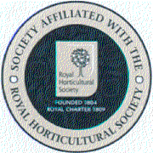
EPSOM GARDEN SOCIETY

‘HAVE A GO AT A SHOW’
HOMECRAFT CRIB SHEET

- If you are pleased with it, put it in! Be aware however that judges are probably not expert at modern art appreciation and will be just looking for a clean and tidy approach. Picasso wouldn’t win a prize at a Flower Show because he would put the eyes in the wrong place!

- When sewing and knitting, the judge will check inside for neat sewing up. Items of clothing should be new and unworn.

- Craft items should be well proportioned that show a mix of skills and techniques as per the schedule.

- For space reasons do not enter exceptionally large items, full size quilts are beautiful but take up a lot of room. If you are particularly keen to enter something like this, please notify the Show Secretary in advance.

- Always check the schedule for sizes of paintings and drawings, these are usually a maximum of A4, which would include any frame.

- All homecraft items must be the sole work of the exhibitor. This is particularly relevant with junior entries, it is so easy for the adult to ‘take over’, by all means ‘help’ but don’t do it for them!

- Items must not have shown at an EGS Show before. Judges have long memories!

