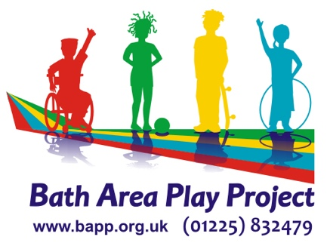

VOLUNTEER APPLICATION FORM

Name _______________________________ Date of Birth ____________

Address ____________________________________________________

___________________________________ Postcode _______________

Email address ______________________________________________

Telephone No. _______________________________________________

Have you volunteered for BAPP before – if YES please give details i.e project/year
___________________________________________________________

How did you hear about volunteering for BAPP?
___________________________________________________________

What experience of working, especially with children, have you had - even informally for family or friends? ___________________________________________________________

___________________________________________________________

Please tick a box for the type of volunteering you wish to do:

- Community Play events (Spring / Summer school holidays): Foxhill/Odd Down  Weston  Southdown  
b) Closed access playschemes (school holidays): The Hut, Twerton  Threeways c) SOFA programme (spring/summer only):  d) Pre-school The Hut,Twerton   e) Family Play Hubs  f) Teenage Rampage  g) Office Admin  h) Garden/ maintenance i) Saturday Club 

I have read and understood the enclosed Staff and Volunteer Code of Conduct and Declaration of Non-Discriminatory Practice and will abide by this whilst at the setting. Signing this form is consent for my data to be stored and used for the purpose of volunteering at Bath Area Play Project.

Signed___________________________________ Date__________________
We understand that the information you give on the application form is confidential and will be treated this way, it will also only be used for the intended purposes. If you would like more information on how your data is stored please view our privacy policy here: https://e-voice.org.uk/cypn/files/view/bappdocuments/Bath_Area_Play_Project_Privacy_Notice_(1).pdf

Please write the Names and Addresses of two people who we can contact for a reference for you. One should be your form teacher or tutor and the other can be a community member (not family) who knows you well.

Name __________________________ Name __________________________

Address ________________________ Address _________________________

_______________________________ ________________________________

_______________________________ ________________________________

Email address:___________________ Email address:_____________________

Post Code ______________________ Post Code________________________

Telephone No. __________________ Telephone No. _____________________

How do they know you? ___________ How do they know you? _____________

______________________________ _________________________________

Please let us know if there is anything we should know about you in order to support you to volunteer with us:

Do you hold an Enhanced DBS Disclosure? YES/NO

If No, would you be willing to complete one? YES/NO

If yes, then please bring your certificate when you come to meet us.

Please return this form to:
Roz King
roz@bathareaplayproject.co.uk

Bath Area Play Project, Odd Down Community Centre, Bath BA2 2TL

Office Use Only

 | Date received / completed | Seen / approved
Reference 1
Reference 2
Code of practice
Declaration of ADP

