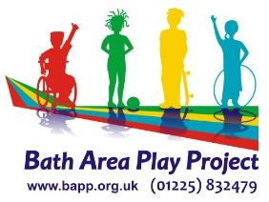

REQUEST FOR NURTURE GROUP
Please complete EVERY section of the form
🗹 Please tick where appropriate (delete empty box first and paste ticked box)

Request by:
(Requesting school/academy)
Contact Person and Phone Number:
Position Held:

Child/Young Person |  |  | Date of Birth | Year Group
Forename(s) |  | Surname
Gender |  | Ethnicity

Address: |  | Telephone Nos:
Name of Parents/Carers (and address if different from above): |  | Relationship (indicating parental responsibility):

 | Yes | No
Does the child have a plan? (PLEASE CIRCLE) | CP CHIN CAF
Does the child have a physical disability or any mental health issues? If yes, what?

Does the child have any allergies or medical conditions we need to be aware of? Does the child have any dietary requirements, If yes, what?

Does the child/young person have a THRIVE assessment? If yes, what stage are they can you provide further details over leaf.
Does the child/young person have a Special Educational Need/ EHC Plan? If yes, please provide further details over leaf
Are there any issues with attendance?

Brief contextual background. Is there anything going on for this young person outside of school such as bereavement, move, changes to family structure, history of domestic violence...

What is going well for this young person either at school or at home and what are their strengths. Such as making academic progress, engages in after school clubs, good peer network…

Why are you referring this young person? Eg Build confidence, play skills, peer relationships… Can you tell us more about how this need might be demonstrated by the young person?

Please give details of Thrive assessment, EHCP, and other interventions that the young person is being supported in and any other information that is relevant.

Please tick to confirm you have verbal consent from parent and young person to attend the Nurture Group and date received.
Please tick if consent is given by Parent/Carer for photos/film to be taken during sessions:
◻ Publicity purposes, including social media Potential feedback for family and school
◻ For a record of our own work which would not be shared outside of the organisation
Please tick if parent consents to being contacted by BAPP to receive feedback at the end of the NG cycle.

