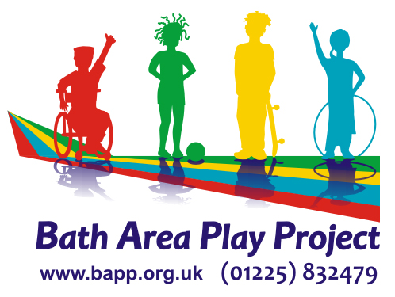

Odd Down Community Centre
Booking Form 2024 Odd Down Community Centre,
Odin’s Road, Odd Down,
Bath, BA2 2TL
Reg. Charity No. 1013897
Date(s) Required: ___________________________

Times from: ________________until: ___________________

Your Name: _______________________________________

Address: ______________________________________ Postcode: __________

Email Address: _________________________________________

Telephone – Home: __________________ Mobile: _________________

What rooms / space do you require?

Lounge £12 per hour

Main Hall £18 per hour

Sole use of Lounge and Kitchen* £18 per hour
(* please delete as appropriate)

Small Meeting Room £9 per hour

Outside Court £10 per session

Use of Kitchen is £5 per session

Please enclose £_________ deposit as agreed

Hire Charge: £________ per hour Total Charge: £________

For evenings after 5pm and weekend bookings, there is an additional charge of £25 for opening and locking up where you are not a keyholder.
I have read and agree to the Terms and Conditions of Hire, to sending a Risk Assessment & DBS where work with under 18s/vulnerable adults, and all staff & users will be Covid-free

Signature of hirer: ____________________________ Date: ____________

